Authors: Kalle Lassila, Aapo Alanen, Jarno Suoraniemi

Printed Thermistor tests

# Version 1

The resistance of the ptc sensor at room temperature is about 1,46MOhm. PTC sensor’s resistance increases with temperature. Testing will be done utilising a simple voltage divider and test equipment. Later versions will include digital implementations with a microcontroller.

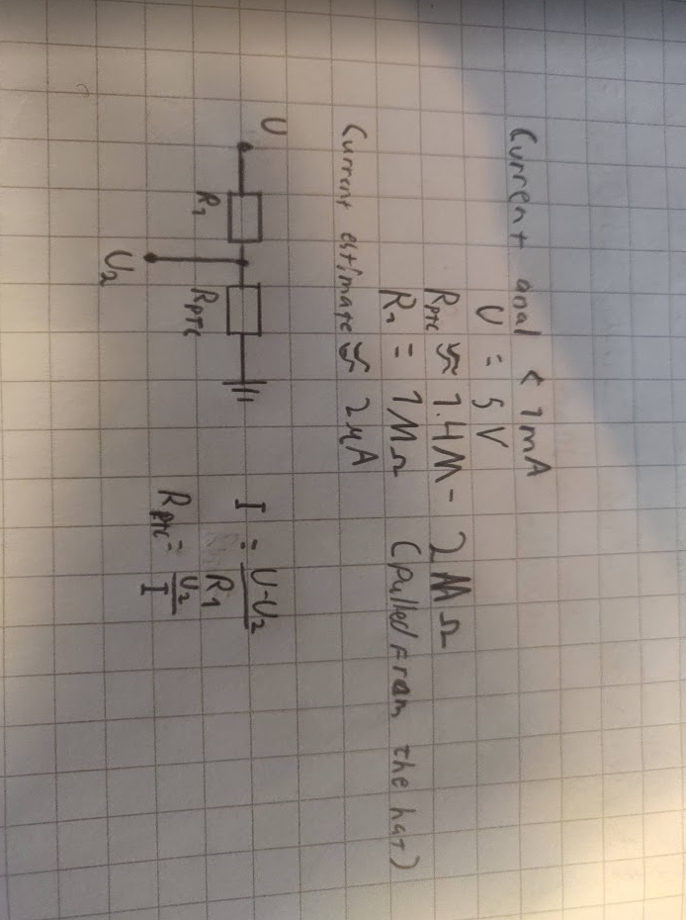

1Very professional test setup

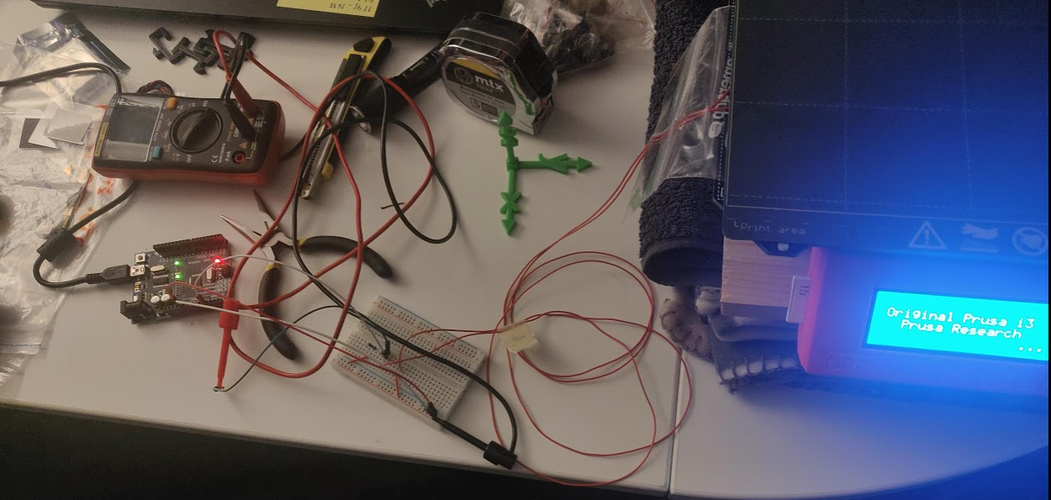

### Problems

PTC sensors can be read with just Arduino analog input. But NTC sensors require some hardware to be measured.

# Versions 2



Picture from ntc sensor measurement. Needs some averaging to compensate for powerline noise.

### 

Picture of current schematic. Arduino internal resistance (about 100Mohm) is currently in parallel with the sensor. That must be chanced to be in parallel with the series resistor. Below a picture of the new schematic.

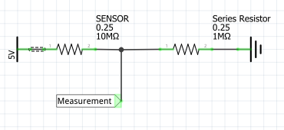

# Versions 3

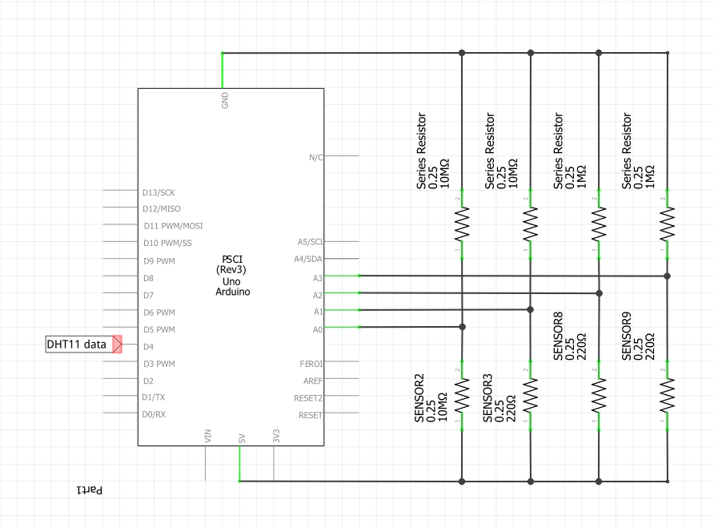

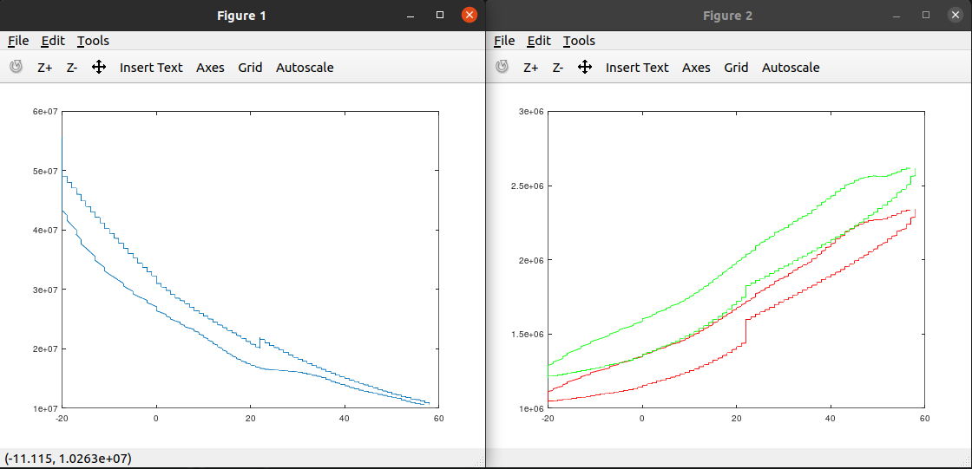Schematic looks like this. I simplified the program to be as simple as possible because I couldn’t make the previous version stable enough to be used in measurement. Octave code at the end of the document.

### Problems

In current configuration the sensors cannot be used to reliably determine temperature, because the figures from the same event do not match closely enuf. For example, figure 2 “resistance as a function of temperature” above (sensor 8 = red and sensor 9 = green) one temperature value has multiple possible resistances (same color measurements do not match).

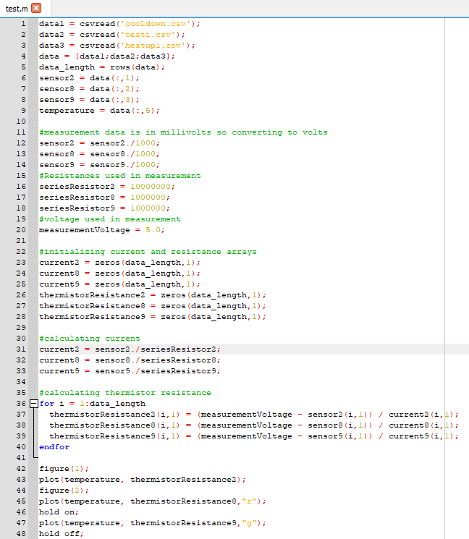

# Version 4

Now instead of having a sensor with a series resistor and measuring from the intersection a different measurement system was built. A PTC sensor is placed in series with a NTC and that intersection is then measured(figure2). 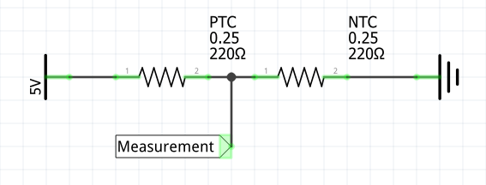

Figure

To slow down temperature change inside the thermos a plastic holder filled with plaster was created to add thermal mass in the test rig(figure3). Also better mounting system for the printed sensors was created for the purpose of not breaking any more sensors(figure4).

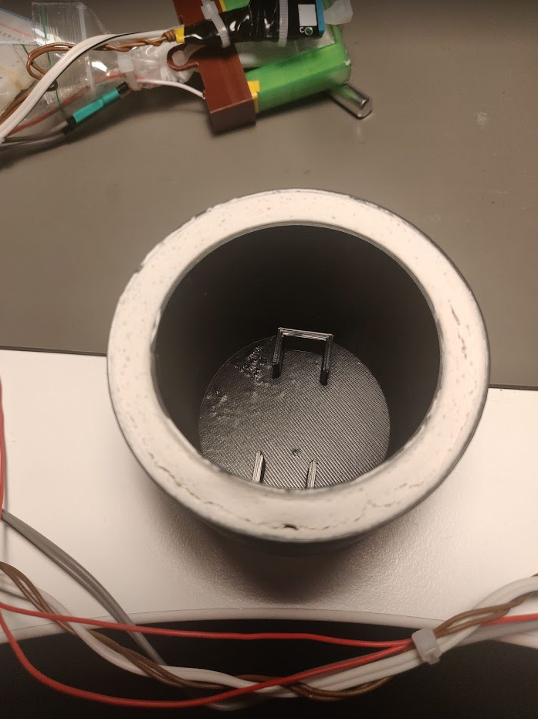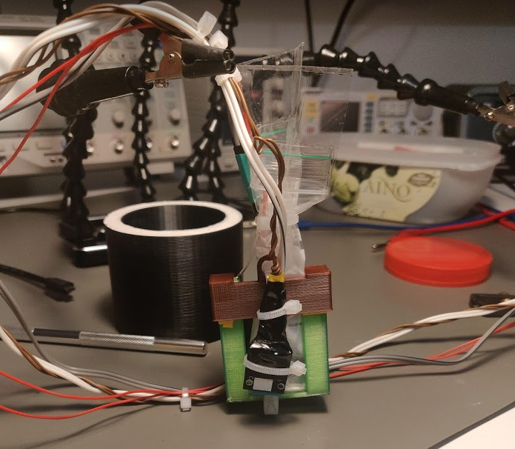

Figure Figure

Cardboard was used for insulation in place of the original lid as the wires could not fit(figures5, 6 and 7).

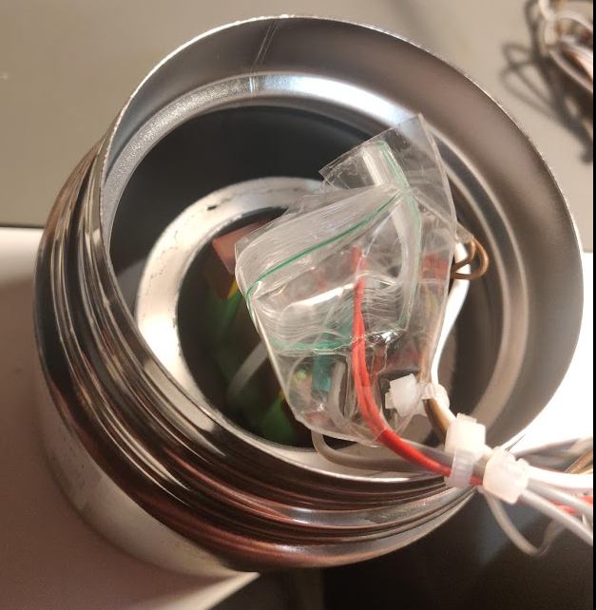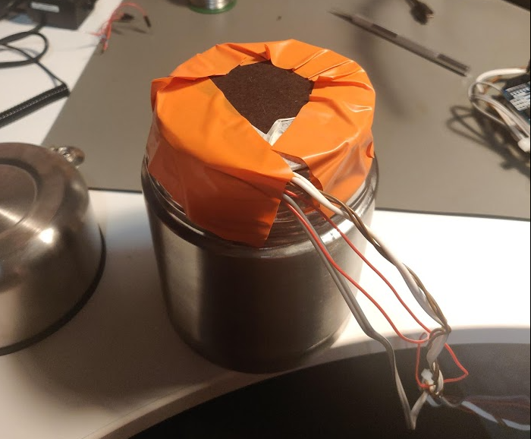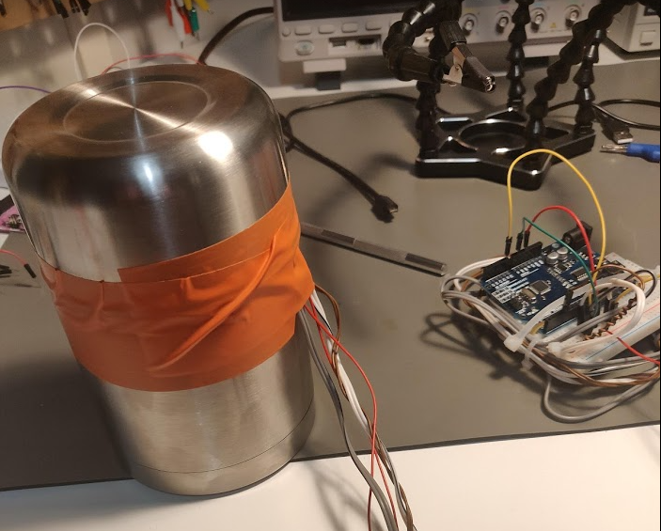

Figure Figure 6 Figure7

During test1(figure8) the thermos went in the freezer from room temperature(23C) and was taken out to test hysteresis when the reading inside was 12C(figure9). Thermistor was placed back in the freezer after the temperature inside reached 15C. Thermos was taken out again when temperature reached 0C and placed back in when temperature was at 6C.

During test2 the thermos was taken from freezer(-20C) and placed to room temperature and back to freezer when temperature reached -14C. The temperature kept rising to -11C when placed in the freezer(temperature changes have taken quite a while to propagate inside the thermos, as you can see when comparing the events of placing thermos in and out of freezer and looking those events from the measurement data). Temperature inside was -13C when the thermos was placed back to room temperature.

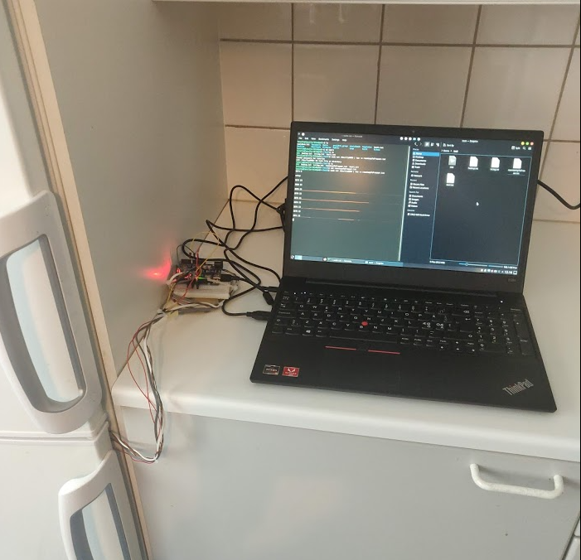 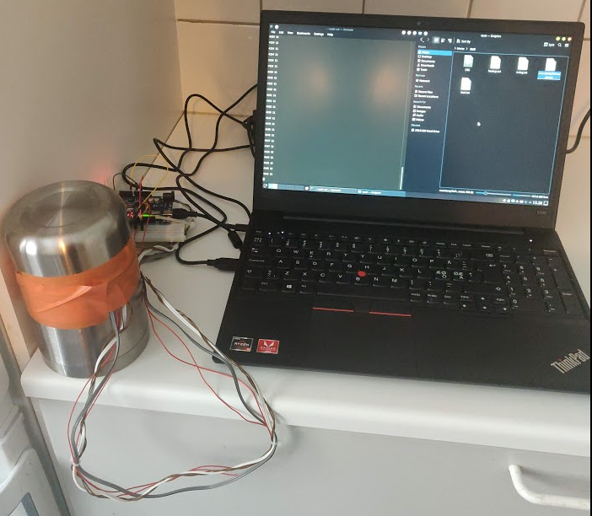

Figure Figure

### Results

Picture of the resulting graph(figure10). The graph looks usable the variation is about +/-2 decrees which is the same as the DHT11 sensor used for calibration. Hysteresis looks to be about 3 decrees.

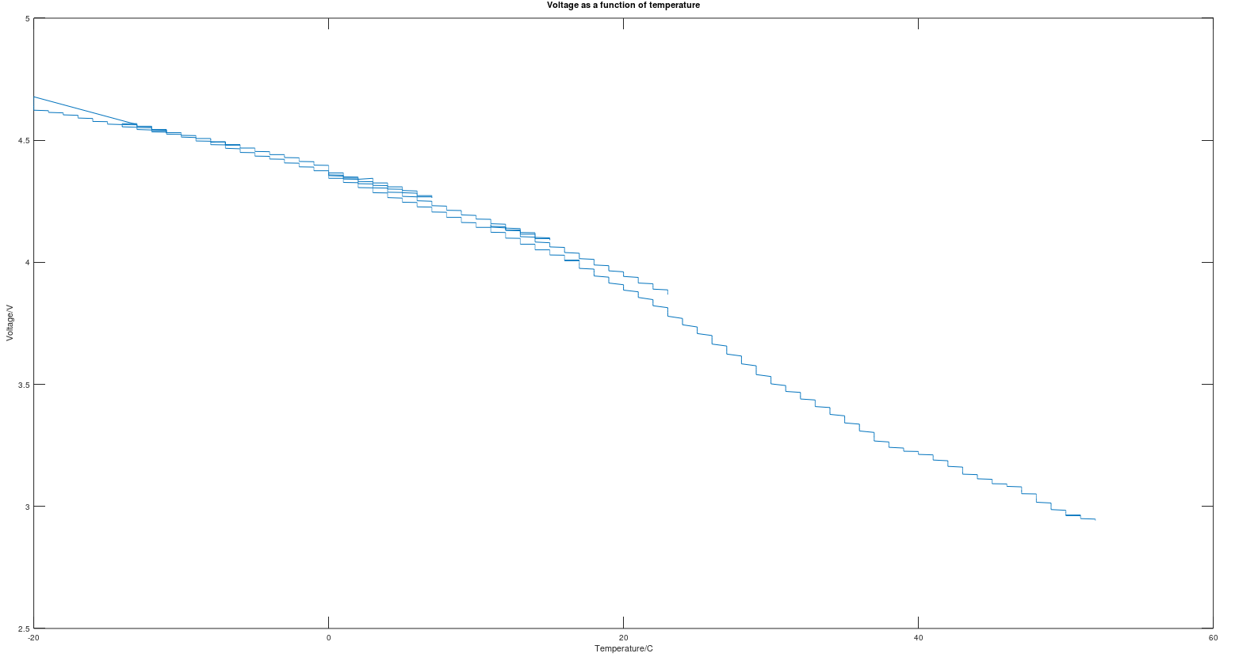

Figure

### Problems

As of now the sensor data seems to be very usable.